IOT Electronic Door Opener

There has been a need of controlling Electronic doors remotely for automation and security purposes. This project tries to fulfill the same using the IoT technology implementation over the electronic door lock making it a super advanced door opener cum locking system. The objective of achieving automation and security is simultaneously achieved using web connectivity of the project with IoT Gecko website. IOT Based Electronic Door Opener Project is controlled by ATmega family microcontroller. The project communicates over internet using WiFi module. We use a demo model of door as shown in the video. On the IOTGecko website once the authorized person logs in he/she gets a direct access of the door to open or close it, no matter how far the door is physically from him/her. When a command of opening the door us received from the web interface the controller instructs the relevant drivers to start the motor of the door in a particular direction till the door fully opens and then stop. Likewise, when the system receives the command to close the door the controller instructs the drivers of the motor rotate in counter direction till the door fully closes. In this way the automatization and security is achieved using this project which gives access of the door authorized person even though they are physically present at some remote location from the door.

Block Diagram
: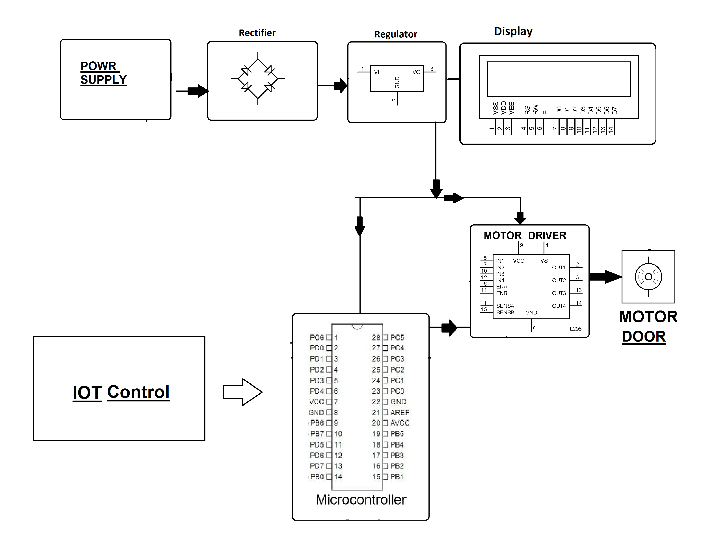

Hardware Specifications
- Power Supply Adapter
- Rectifier
- Regulator
- Atmega Microcontroller
- LCD Display
- Mini Motorized Door
- Wifi Module
- Resistors
- Capacitors
- Diodes

Software Specifications
- Arduino Compiler
- MC Programming Language: C
- IOTGecko

